Student’s name | …………………………………………………….…… | Grade | 2
Subject | Computer | Week No. | 6
Lesson Title |  | Unit
Midterm Exam Worksheet

Question A: Match the following

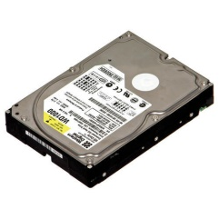 | UPS
 | HEADPHONE
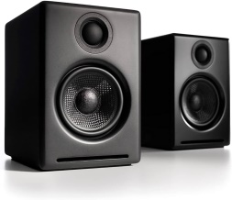 | HARD DISK
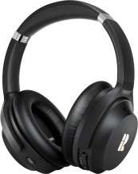 | PROCESSOR
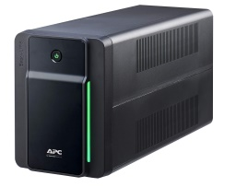 | SPEAKER

Question B: Match the following

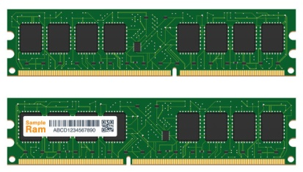 | WEBCAM
 | PRINTER
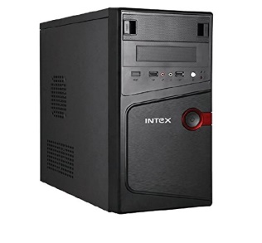 | RAM
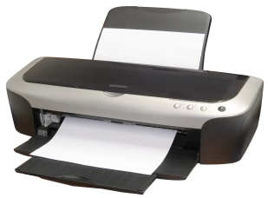 | DISC
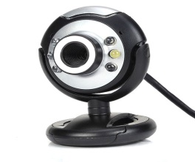 | CPU

Question C: Fill in the blank with the correct file types.

File | File Type | File | File Type
 | _______________ |  | _______________
 | _______________ |  | _______________

Question D: Fill in the blanks.
- The memory device that is used to store information in a computer is called as a _____
- All the software are saved in the ___________ drive.
Question E: State whether the statements are True/False.
- Files of same name cannot exist in same folder,
_____________
- Hard disk is not a memory device.
_____________

ANSWER KEY
Question A: Match the following

 | UPS
 | HEADPHONE
 | HARD DISK
 | PROCESSOR
 | SPEAKER

Question B: Match the following

 | WEBCAM
 | PRINTER
 | RAM
 | DISC
 | CPU

Question C: Fill in the blank with the correct file types.

File | File Type | File | File Type
 | Picture |  | Document
 | Video |  | Audio

Question D: Fill in the blanks.
- The memory device that is used to store information in a computer is called as a ROM
- All the software are saved in the Hard drive.
Question E: State whether the statements are True/False.
- Files of same name cannot exist in same folder,
True
- Hard disk is not a memory device.
False

